## **SHORT AND LONG QUERY ANALYSIS DASHBOARD**

# **Snowsight Dashboard Setup**

## 1. Create a Dashboard

Login to the account and navigate to the **tab dashboard** in the left side options ,then click on the **+dashboard** option highlighted in blue to create a new dashboard.

## 2. Name the dashboard

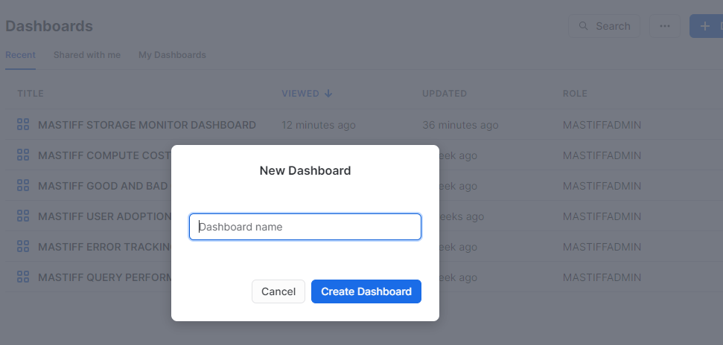

Next step is to give an appropriate name to the dashboard and click **Create Dashboard**.

## 3. Setup the Role and Warehouse

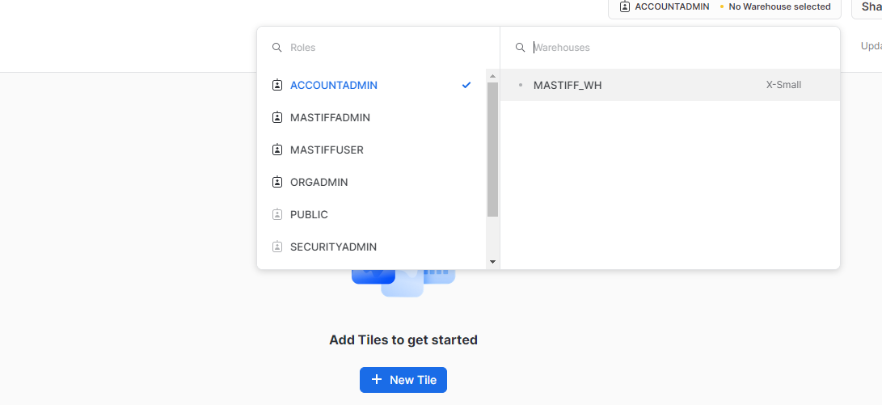

## 4. Creating KPIs and Charts

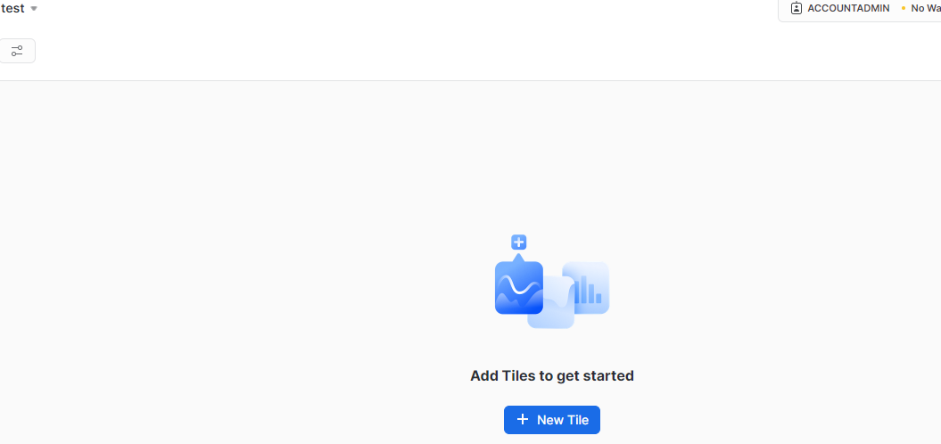

To create KPIs and charts, start by adding a new tile by clicking **+New Tile .**

## 5. Adding names to the KPIs and Executing the queries.

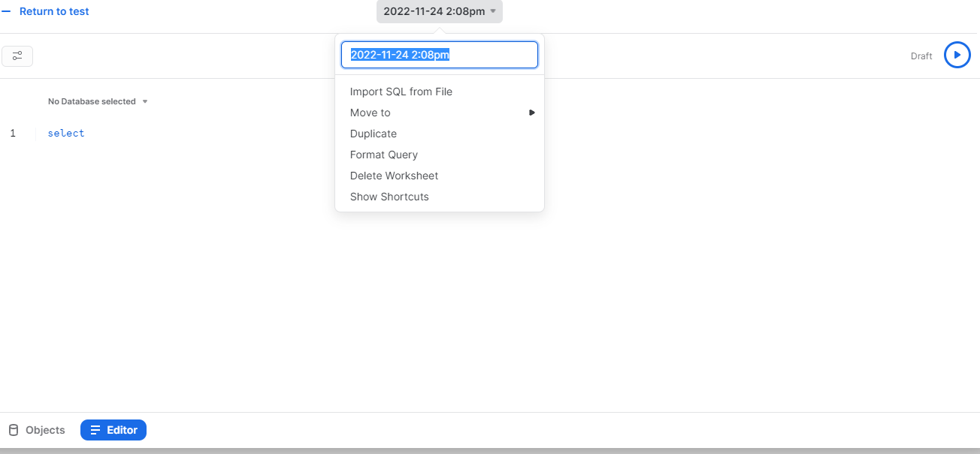

We can name the KPI by clicking the date followed by the time and changing it to the required name. To execute a query, type in the editor and click the run button to get the desired results.

**Note :** Before you create all the dashboards in Snowsight, Use the role **MONITOR_ADMIN** and warehouse **MONITOR_WH** to create dashboards in SNOWSIGHT for Watchkeeper.

## **SHORT AND LONG QUERY ANALYSIS DASHBOARD SETUP**

## **Filters**

**Customize the filter query's refresh frequency to align with your requirements. If you regularly analyze dashboards, consider refreshing it daily for up-to-date data. However, if dashboard analysis is infrequent, opt for "never refresh" to reduce unnecessary costs. Keep in mind that choosing "never refresh" means running filter query manually when utilizing the dashboard, which can be done from the filter section.**

Create the filters which will be used in this dashboard

### **Role Filter**

**Display Name** :- ROLE

**SQL Keyword** :- ROLENAME

**Role** :- MONITOR_ADMIN

**Warehouse** :- MONITOR_WH

**Options Via** :- Query

**Write Query** :- SELECT DISTINCT(ROLE_NAME) FROM SNOWFLAKE.ACCOUNT_USAGE.QUERY_HISTORY;

Go for the below selections :

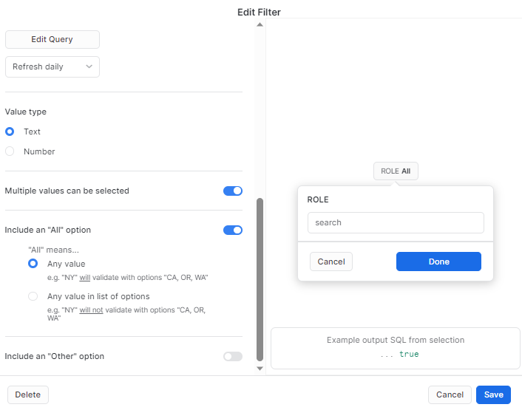

### **User Filter**

**Display Name** :- USER

**SQL Keyword** :- usernamefilter

**Role** :- MONITOR_ADMIN

**Warehouse** :- MONITOR_WH

**Options Via** :- Query

**Write Query** :- select distinct(user_name) from SNOWFLAKE.ACCOUNT_USAGE.QUERY_HISTORY;

Go for the below selections :

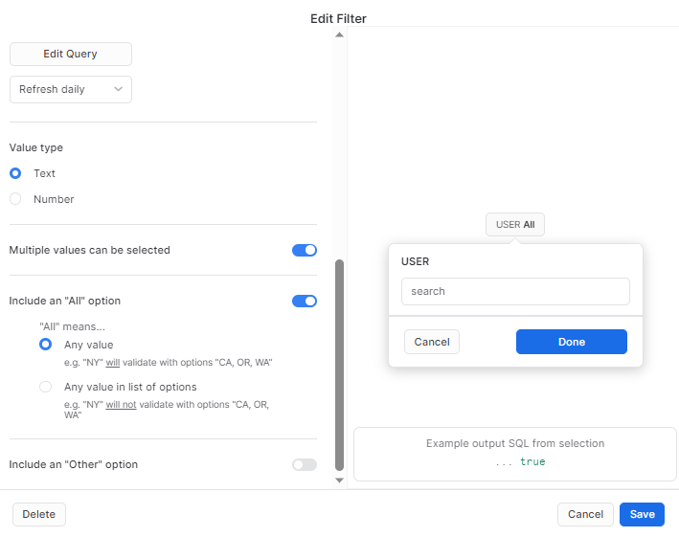

### 

### **1 No. of Short Queries**

select count(*) from "MONITOR_DB"."PERFORMANCE_MONITOR_SCHEMA"."LONG_QUERY" where performance = 'SHORT' and role_name = :ROLENAME and user_name =:usernamefilter;

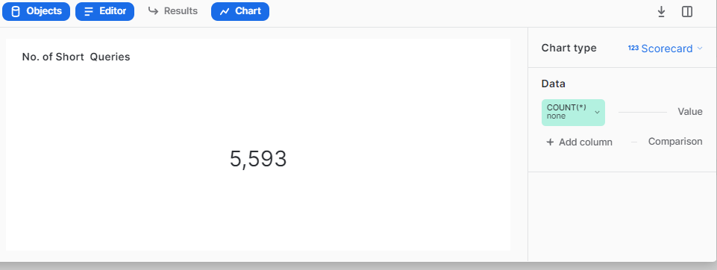

### **2 No of Long Queries**

select count(*) from "MONITOR_DB"."PERFORMANCE_MONITOR_SCHEMA"."LONG_QUERY" where performance = 'LONG' and role_name = :ROLENAME and user_name =:usernamefilter ;

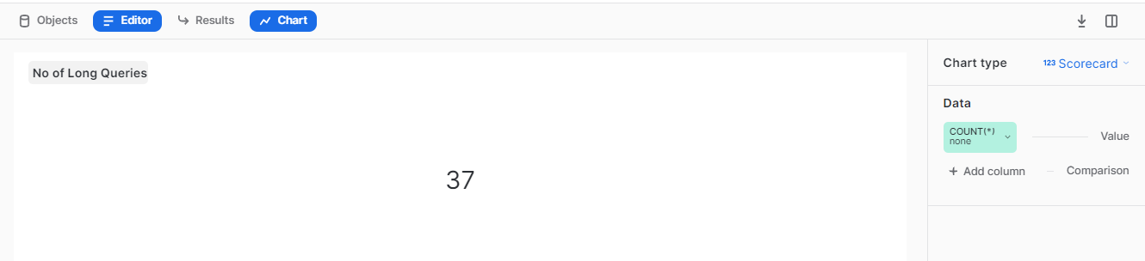

### 

### **3 OVERALL LONG QUERY PERCENTAGE**

select long_queries, total, ROUND(long_queries/total*100, 2) || '%' AS LONG_QUERY_PERCENT from (select count(*) as total,

(select count(*) from "MONITOR_DB"."PERFORMANCE_MONITOR_SCHEMA"."LONG_QUERY" where performance = 'LONG' and role_name = :ROLENAME and user_name =:usernamefilter) as long_queries from "MONITOR_DB"."PERFORMANCE_MONITOR_SCHEMA"."LONG_QUERY" WHERE role_name = :ROLENAME and user_name =:usernamefilter);

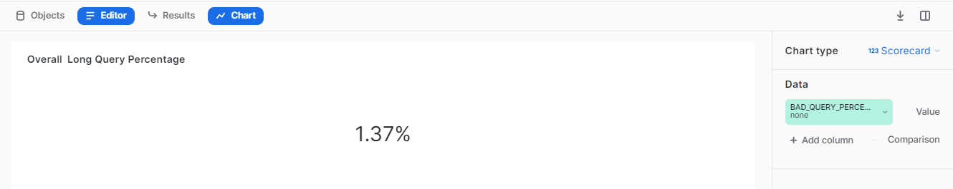

### **4 AVG LONG QUERY IN MINUTES**

select round(avg(total_elapsed_time),4)

from "MONITOR_DB"."PERFORMANCE_MONITOR_SCHEMA"."LONG_QUERY" where performance = 'LONG';

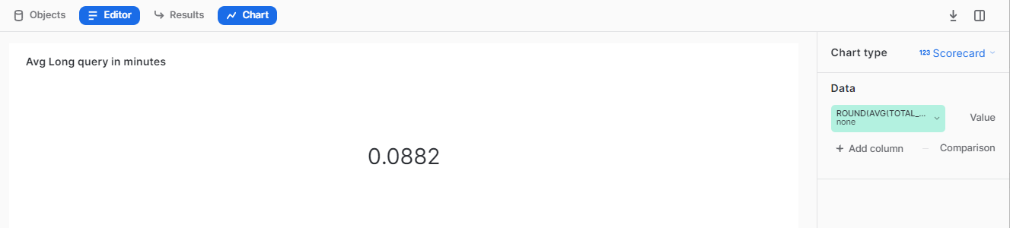

### 

### **5 TOP LONG QUERIES**

SELECT QUERY_ID, QUERY_TEXT,b.TOTAL_ELAPSED_TIME, WAREHOUSE_SIZE FROM "MONITOR_DB"."PERFORMANCE_MONITOR_SCHEMA"."LONG_QUERY" b WHERE PERFORMANCE = 'LONG' and role_name = :ROLENAME and user_name =:usernamefilter order by b.TOTAL_ELAPSED_TIME desc;

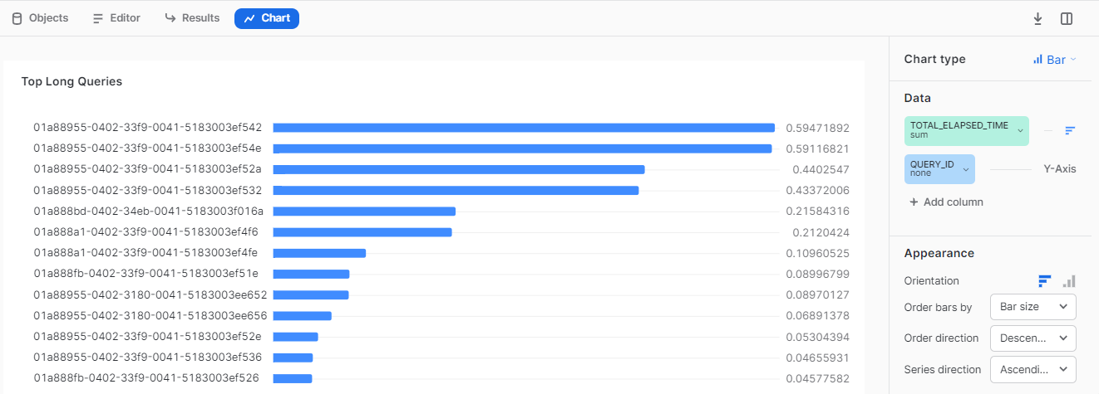

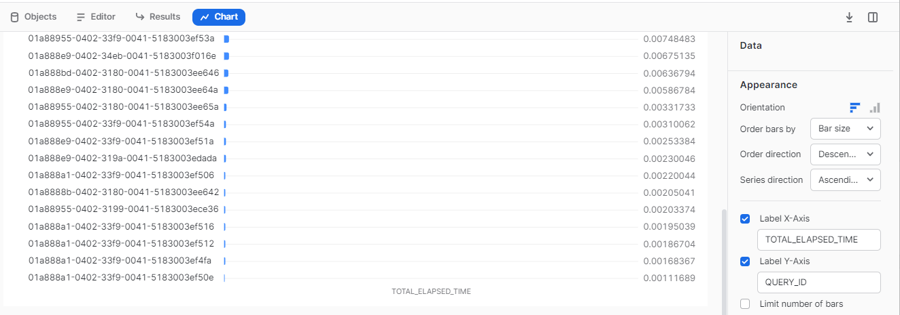

### 

### **6 USER QUERY PERFORMANCE**

select * from "MONITOR_DB"."PERFORMANCE_MONITOR_SCHEMA"."LONG_QUERY";

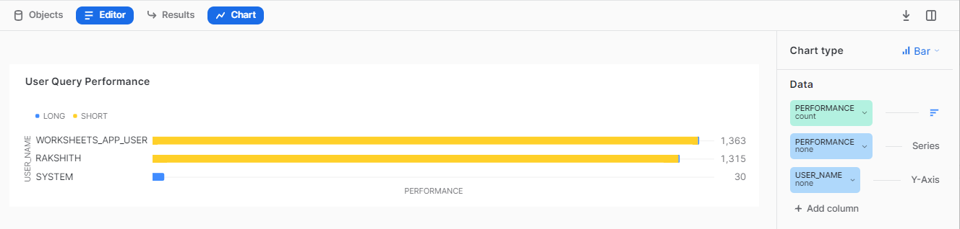

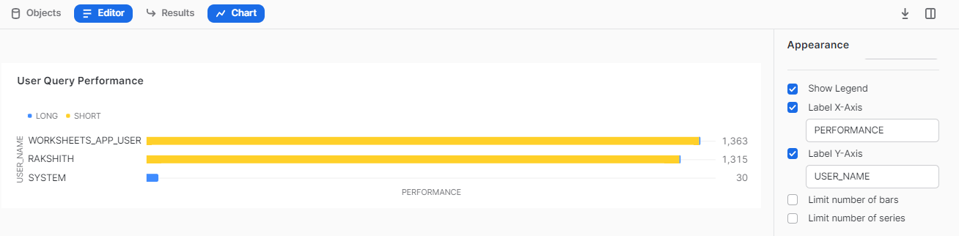

### 

### **7 ROLE BASED QUERY PERFORMANCE**

select * from "MONITOR_DB"."PERFORMANCE_MONITOR_SCHEMA"."LONG_QUERY";

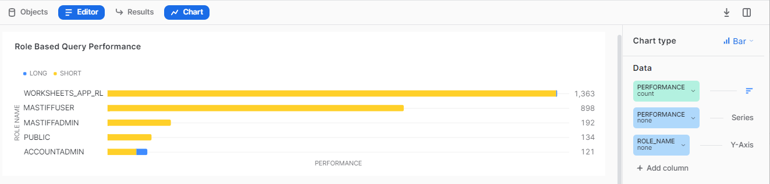

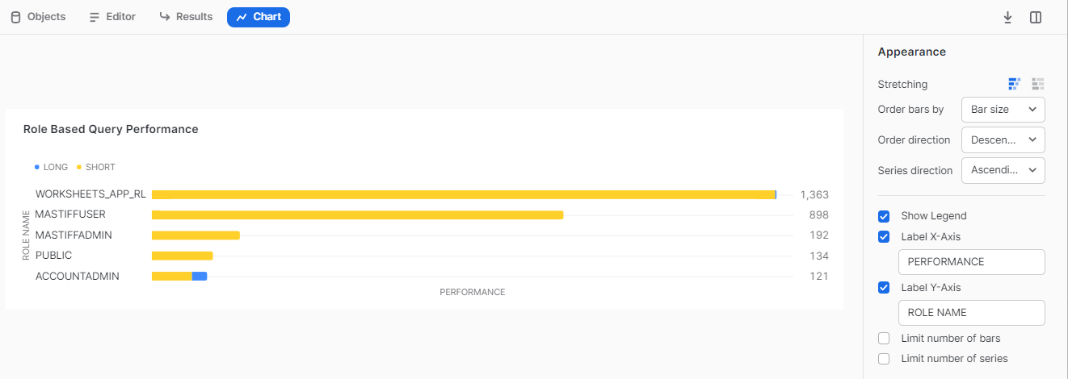

### **8 WAREHOUSE QUERY PERFORMANCE**

select performance, IFNULL(WAREHOUSE_NAME , 'CSL') AS WAREHOUSE_NAME from "MONITOR_DB"."PERFORMANCE_MONITOR_SCHEMA"."LONG_QUERY" where role_name = :ROLENAME and user_name =:usernamefilter;

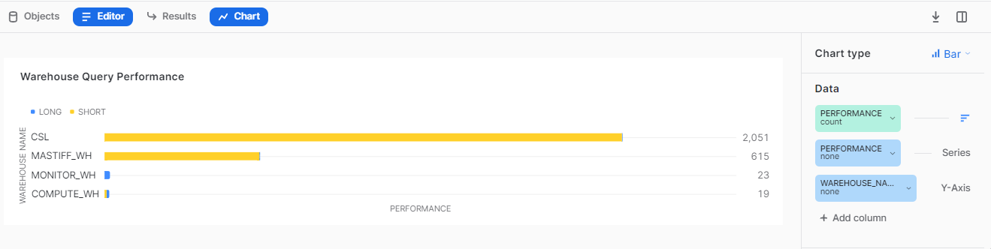

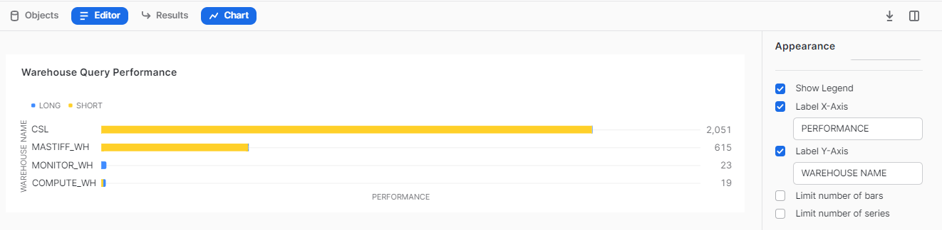

### 

### **9 DATABASE QUERY PERFORMANCE**

SELECT TOP 9000 PERFORMANCE, IFNULL(DATABASE_NAME , 'NO DATABASE') AS DATABASE_NAME

from "MONITOR_DB"."PERFORMANCE_MONITOR_SCHEMA"."LONG_QUERY" where role_name = :ROLENAME and user_name =:usernamefilter;

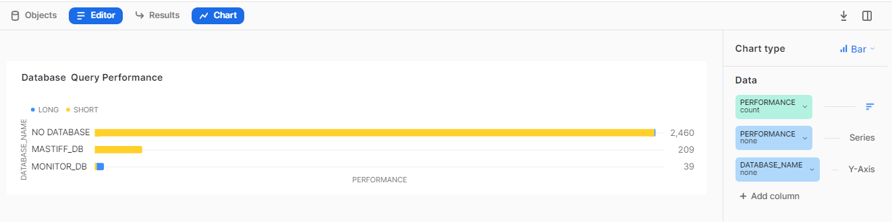

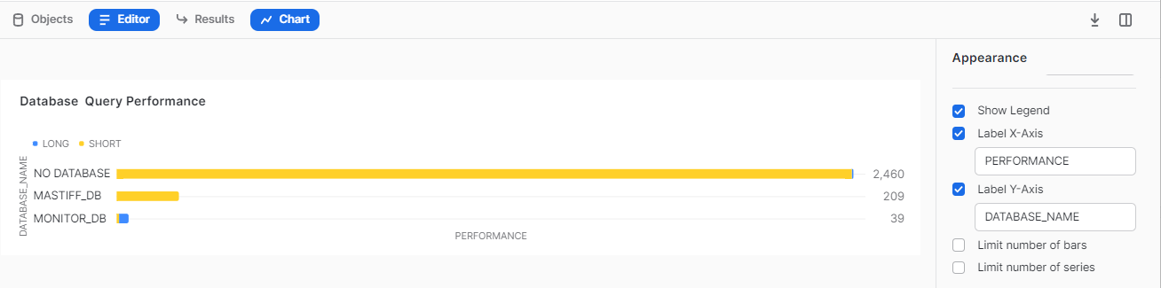

## **Best Practices -**

* If you have records more than 10000 then select only top 9999 ( refer. link:- <https://docs.snowflake.com/en/sql-reference/constructs/top_n.html>) to create a chart as Snowsight only supports data to be visualized till 9999 rows.
* It's preferable to do aggregation in the query itself rather than to do it in Snowsight UI.
* Adjust the round off value as per your requirement ( e.g - round((<column_name>), n) where n = natural number ).
* On hovering over any filter, visuals getting filtered would be highlighted.
* To make filter interaction more user friendly, you can even use color coding.
* Customize the refreshment time of the filter query according to your specific needs.